Data backup from Ec2 to S3

Launch an instance:

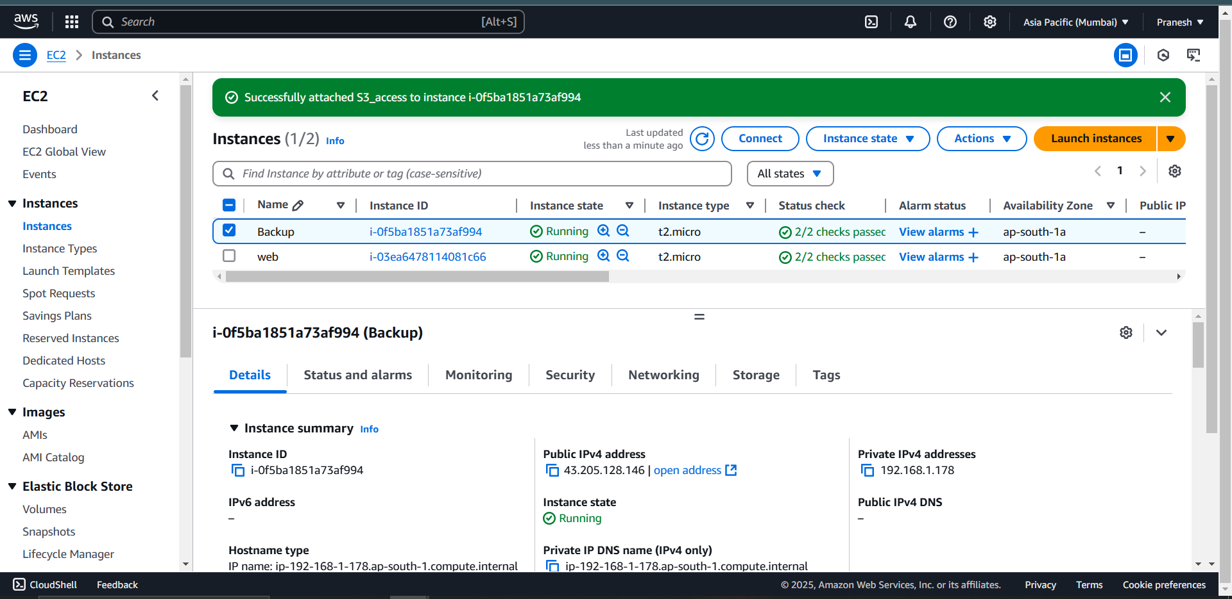

Create an IAM role for ec2 to access the s3 buckets

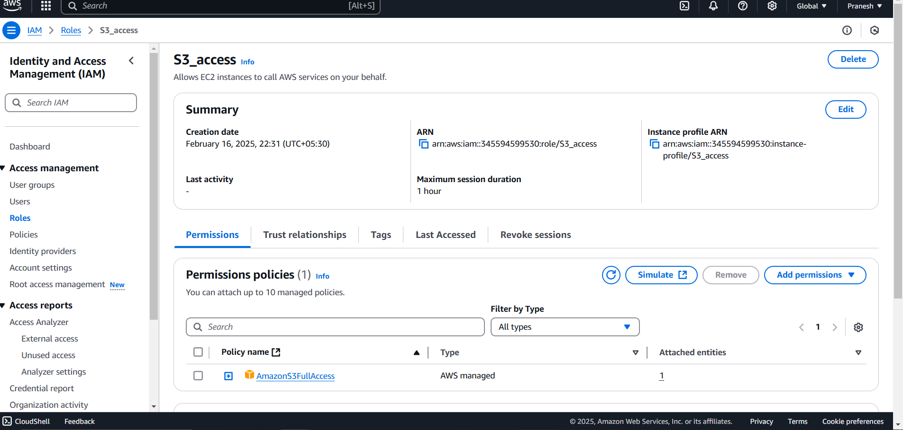

Create a S3 bucket for backup data storing:

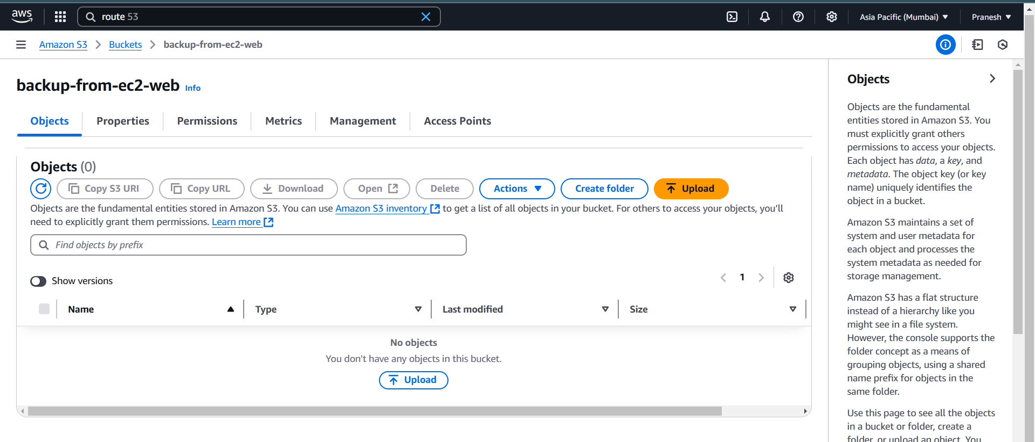

Attach the IAM role to the ec2 instance having s3 access

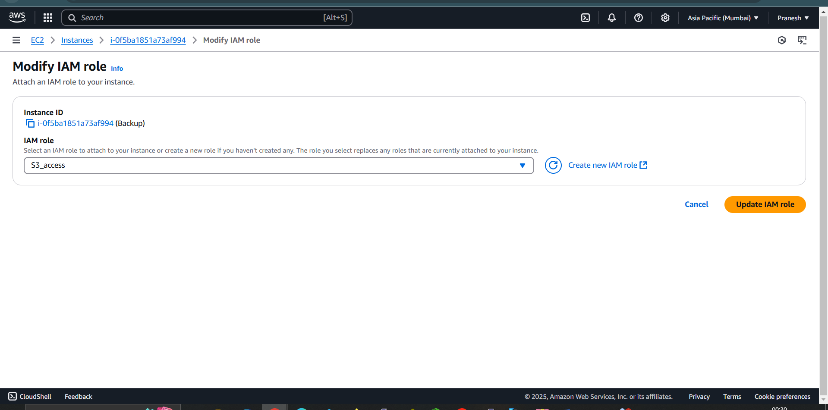

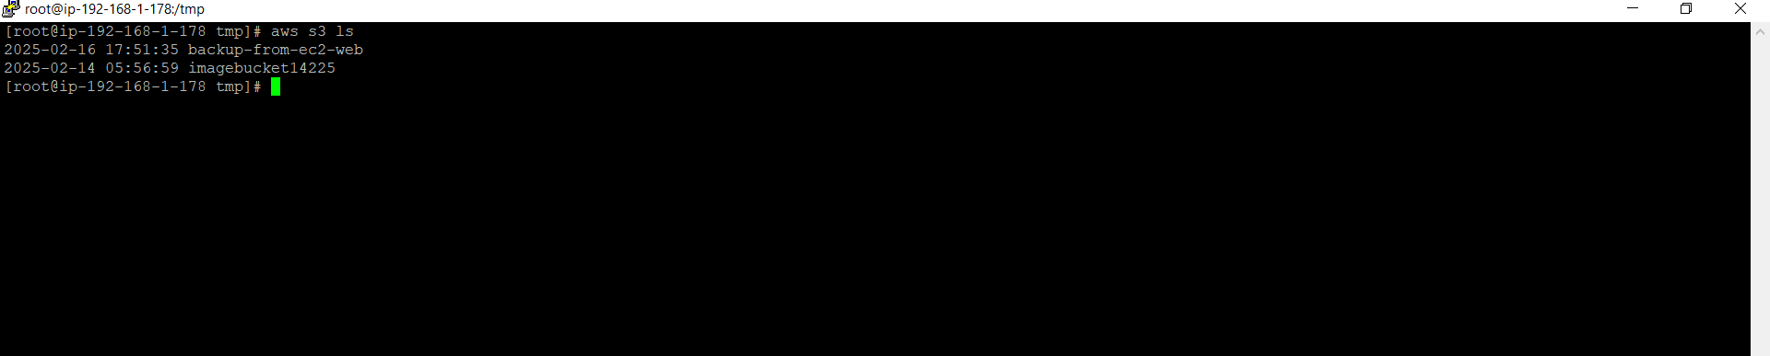

Write a script for backup of the data in one dir to S3 bucket:

Backup.sh:

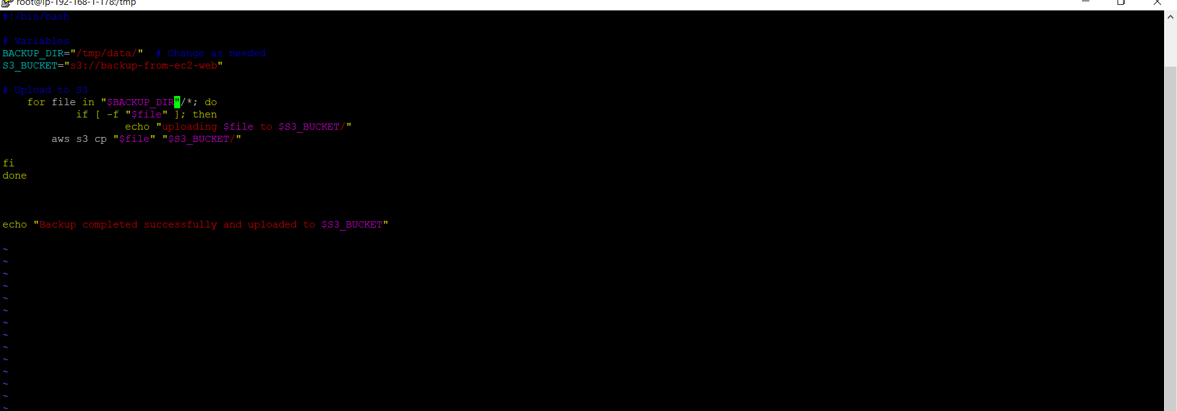

Write a Restore script to restore from s3 to restore dir:

Restore.sh:

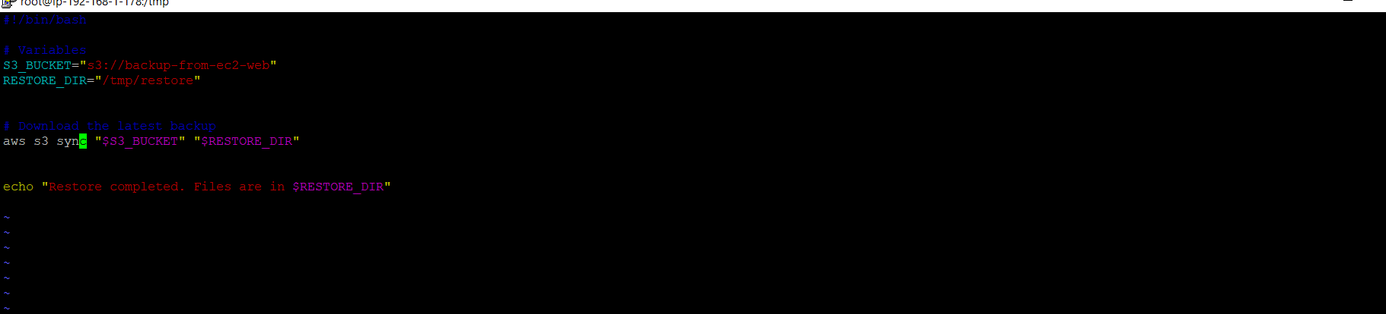

(cron job)

For automating this backup create a crontab:

--crontab -e

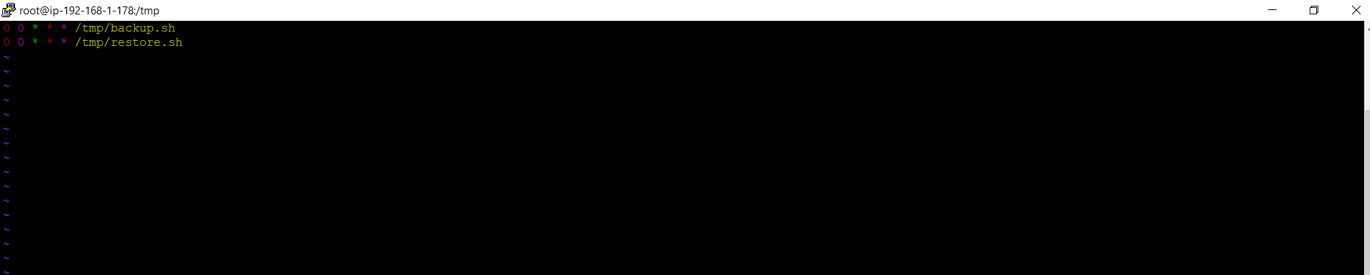

Run the script :

./backup.sh

./restore.sh

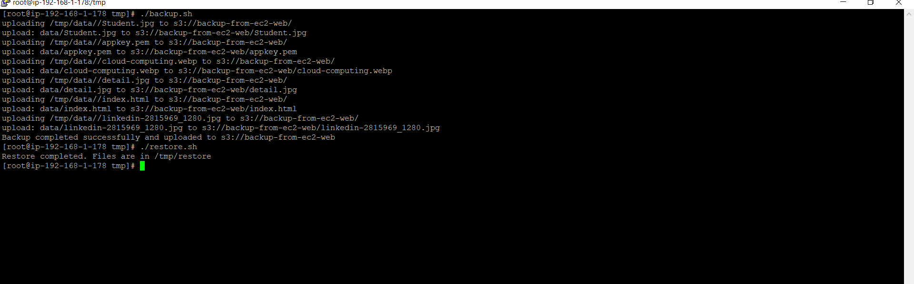

Backup data from EC2 machine to S3 bucket:

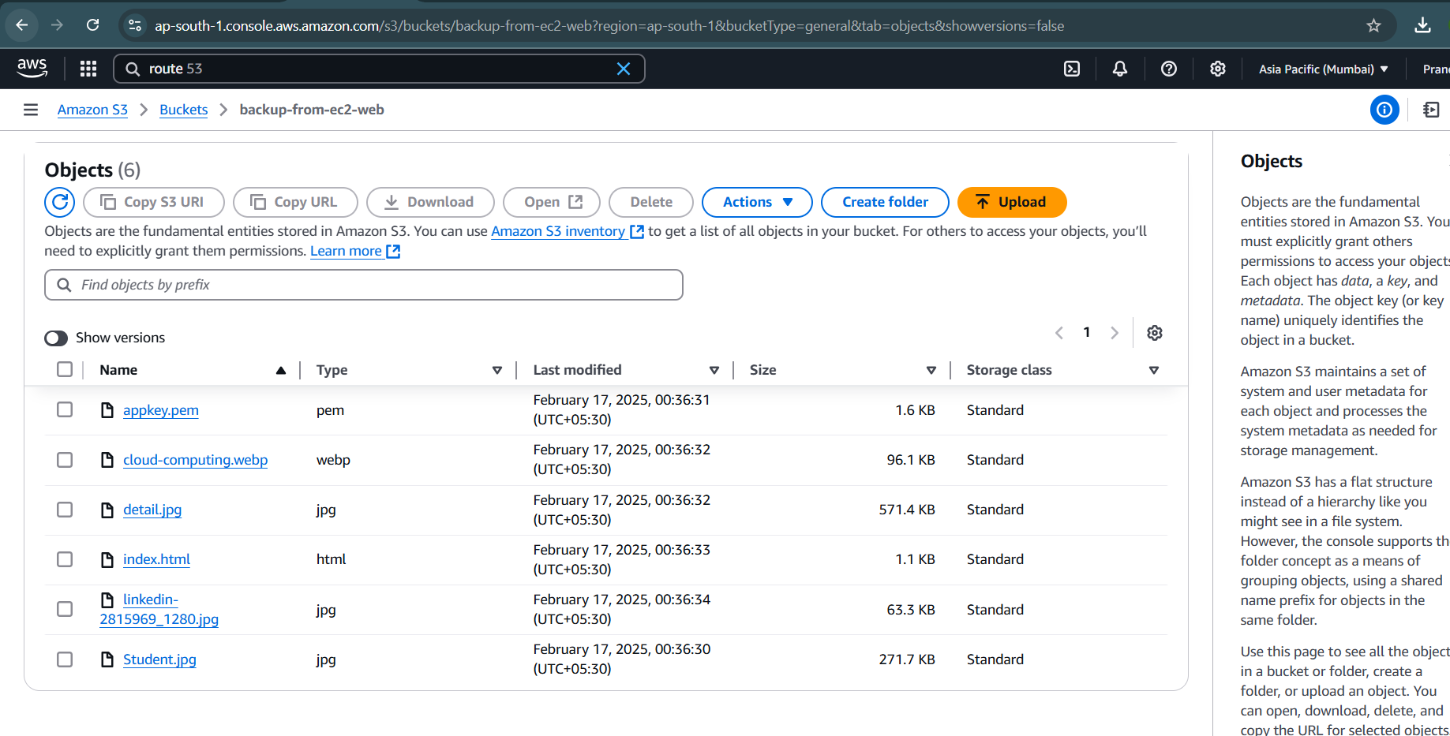

Restore data from S3 to EC2 instance:

